ILLUSTRATED PRESENTER SCRIPT
Amazon GREF
Facilities support
From voice self-service to reviewed human follow-up in Salesforce.
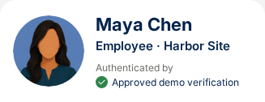
Verified employee and workplace context in the native Salesforce sidebar.
Maya Chen checks room 4B, then reports that room 4C is cold again. Alex uses the carried-forward context and Copilot guidance to review a facilities follow-up and request help finding another room.
DEMONSTRATION SETTING  Fictional Harbor office, floor 4. Story clock: October 12, 2026, 9:10 a.m. New York time. “Today,” “yesterday” and the 10 a.m. workshop follow that authored clock. | HOW TO READ THIS VERSION  Dialogue is suggested presenter wording; live AI wording can vary. Screenshots are actual component captures from Connect browser calls and a Salesforce stereo rehearsal. Alex is the spoken role; saved tasks use the signed-in presenter’s name.
Core journey only • Voice 4927:v3 • Copilot 4928:v10 • DevSDO Amazon GREF • +1 800-520-8156
The opening reflects the deployed recorded welcome and verification flow. Human pickup and headset audio remain for the later live test; the optional Spanish email extension is outside this version.

THE CORRECTED SALESFORCE APP
The familiar console, with GREF context
Employee context at left, the room snapshot and native tasks in Case Summary, and the expanded AI Transfer Summary at right. Inter typography and spacing follow the approved Figma design.
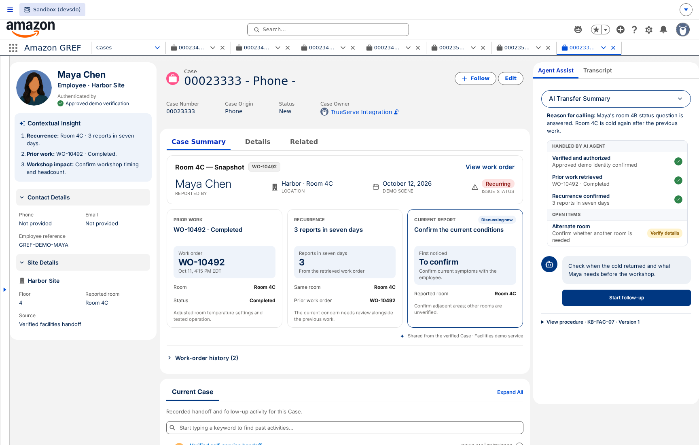
Actual DevSDO Amazon GREF app. The split list is collapsed to show the three working columns.

THE APPROVED FIGMA DESIGN
Read the room snapshot
Prior work, recurrence and current conditions stay distinct. Missing onset or surrounding-room details remain unconfirmed until Maya supplies them.
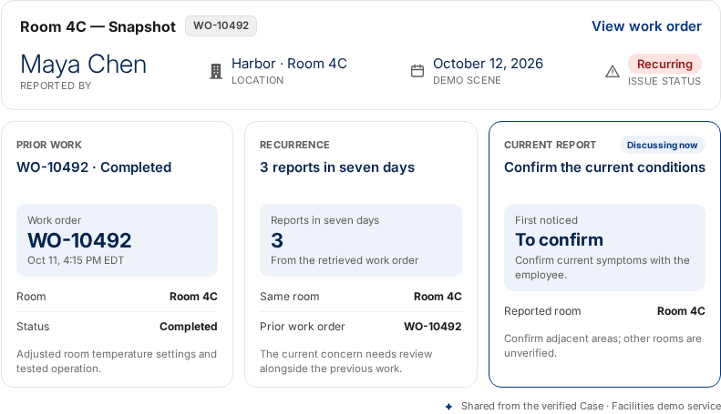
Actual Salesforce component. View work order opens the collapsed related list; review and wrap-up actions appear at the appropriate later stage.

AMAZON GREF / 01

The call opens once
Amazon Connect plays the welcome while the support Case is prepared.
Recorded welcome “Thanks for calling Amazon facilities support. Our AI assistant will help with your workplace request and can connect you with our support team.”  Voice AI “What can I help you with today?”  Maya “I have two things. First, is there an update on the air conditioning request for meeting room 4B at Harbor?”  PRESENTER ACTION  Start the Connect call in Studio Preview, or dial the dedicated number. The recording introduces the service; the AI continues with the first question.  WHAT IS HAPPENING  The initial flow starts asynchronous Case preparation. Conversation startup joins and checks that same operation. Later handoff updates the same Case. Caller recognition does not establish employee verification. | 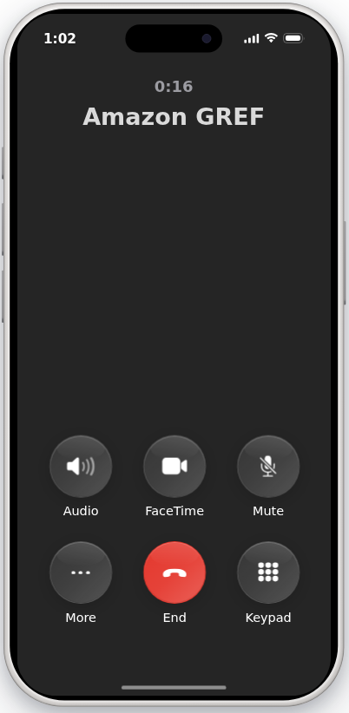  Actual Studio phone during an active Amazon Connect call. The employee remains on voice.

AMAZON GREF / 02

Verify before retrieving records
The caller uses the secure verification page and returns to the same voice call.
Voice AI “To verify, I’ll text you a secure link. Is it okay to send that now?”  Maya “Yes, please text me the verification link.”  PRESENTER ACTION  Open the demo phone notification, then Open link. With v3’s preview setting, the existing in-phone Face ID simulation runs and returns to the call after server confirmation. Actual inbound calls use the real passkey ceremony.  WHAT THE AUDIENCE SEES  The phone labels the ceremony Preview simulation, then shows Face ID confirmed. The voice agent receives the test verification result and retrieves the requested demonstration work order.  CAPTURE SCOPE  These are actual screens from the Connect Preview call. This simulation does not establish real identity assurance or enroll a passkey. | 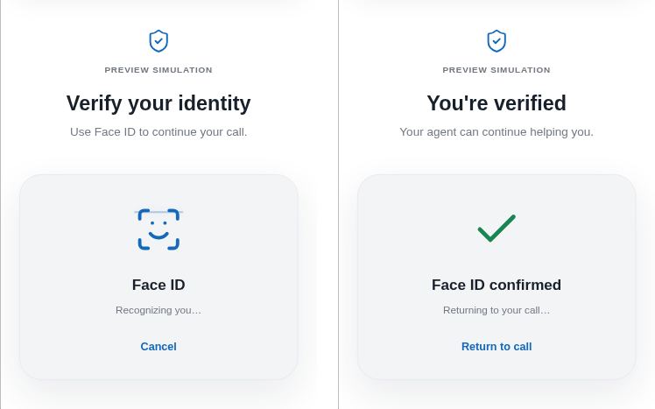  Actual in-phone preview: Face ID simulation, then server-confirmed completion and return to the call.

AMAZON GREF / 03

Answer the room 4B inquiry
A retrieved work order supports the status answer.
Voice AI “The visit for room 4B is scheduled for today between two and four p.m. That’s the current visit window in the request. Did you need anything else on that one?”  Maya “No, that’s all I needed on that request.”  Voice AI “What’s the second issue?”  PRESENTER ACTION  Keep Show AI Activity open for the audience. Point to the completed work-order lookup and the spoken status answer.  RECORD OUTCOME  WO-10481 remains Scheduled. The status inquiry is answered; the maintenance work order is not marked completed. | 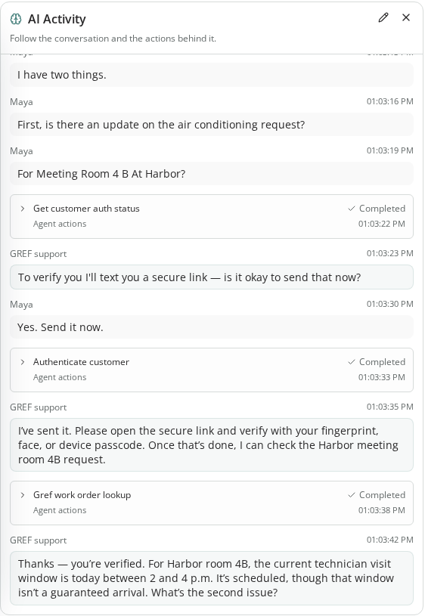  Actual self-service activity panel: permission, verification, completed lookup and the room 4B answer. This panel is for the presenter.

AMAZON GREF / 04

Recognize a recurring issue
The prior completion record and the employee’s new report remain distinct.
Maya “Room 4C is too cold again. This is the third time this week, and we were told it had been fixed.”  Voice AI “Is the cold temperature affecting just room 4C, or the surrounding area as well?”  Maya “As far as I know, just 4C. We have a workshop for twelve people there at ten.”  PRESENTER ACTION  Explain that the AI retrieves room 4C’s history and the approved demonstration procedure before suggesting human coordination.  SOURCES  WO-10492 is recorded as Completed yesterday at 4:15 p.m. The technician note says the settings were adjusted and operation tested. Three temperature reports occurred in seven days. None of this proves the room is comfortable now. | 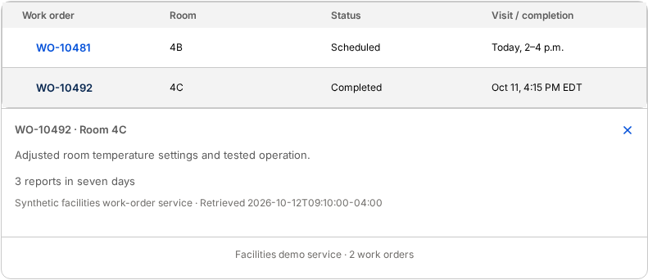  Work-order history in Case Summary, styled as a native related list. WO-10492 is expanded to show its technician note and source details.  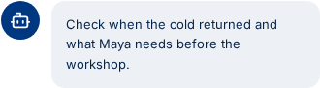  The workspace recommends review of the recurring issue.

AMAZON GREF / 05

Carry the context into Salesforce
The employee accepts the transfer and the existing Case receives the handoff.
Voice AI “The latest work order says the temperature settings were adjusted yesterday. Since the room is cold again and you have a workshop starting soon, I’ll connect you with someone who can coordinate the next step. I’ll pass along what you’ve told me.”  Maya “Yes, please. I don’t want to have to explain it all again.”  Voice AI “I’ve captured the room, the previous request and the workshop details. I’ll connect you now.”  CARRIED CONTEXT  Verified identity reference; location; both intents; recurrence and impact; retrieved work-order IDs, statuses and notes; stated workshop details; answered questions; unknown details; transfer reason; transcript reference.  PRESENTER CUE  Show the saved handoff before Alex speaks. No new repair action has yet been submitted. | 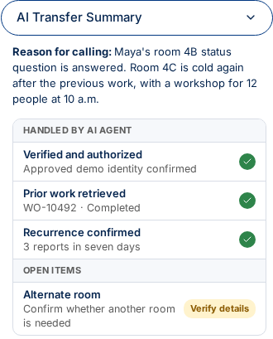  The short AI Transfer Summary is expanded in Agent Assist. Case Summary does not repeat it; the full verified context remains available to the copilot.

AMAZON GREF / 06

Alex picks up the story
The Case header establishes who and where; the history is already available.
Alex “Hi Maya, this is Alex. I can see room 4C is cold again after yesterday’s work, and you have twelve people arriving for a workshop at ten. Let’s get the right follow-up in place.”  Maya “Exactly. We’ve raised this several times already.”  Alex “I’m reviewing the previous work and the follow-up process now.”  PRESENTER ACTION  Acknowledge the repeat contact, then confirm the current impact. Select Start follow-up.  WORKSPACE LAYOUT  The shared console shows employee context on the left, native Case highlights, the room snapshot and collapsible work-order history in Case Summary in the center, and Agent Assist / Transcript tabs on the right.  LIVE PICKUP  For a real handoff, accept the incoming offer in Phone/Omni. These Salesforce screenshots show the component rehearsal; the representative’s answered-call audio path is still awaiting the later test. | Verified employee profile; workplace details are available below.    The native action opens the follow-up form.  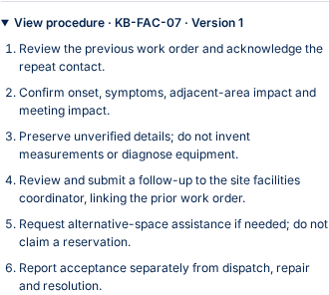  KB-FAC-07, version 1, supplies the review procedure.

AMAZON GREF / 07

Copilot proposes the next step
Guidance is tied to the current Case and cites the supplied sources.
WHAT THE AUDIENCE SEES  Facilities guidance appears inside the existing Agent Assist rail with compact styled cards. The short transfer summary stays expanded through stage changes. Saved Case context supplies the guide, action and exact procedure; the live copilot adds speech capture and post-call summary.  PRESENTER ACTION  Expand KB-FAC-07 in Agent Assist to see the source procedure. Use the guidance to acknowledge the repeat contact and confirm the current impact.  Alex “I’ll review what was done previously and confirm what has changed today, so the follow-up includes the right details.”  KEEP THE DISTINCTION  Copilot suggests wording and fields. Alex reviews them and controls the Salesforce actions. The card does not diagnose equipment, invent an Amazon SLA or confirm a repair. | 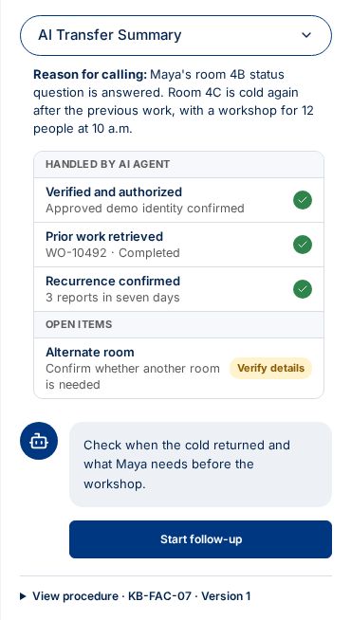  Case-backed guidance alongside 4928:v10 in the shared Agent Assist rail. The procedure is available below the main action.

AMAZON GREF / 08

Ask before filling the onset
A question alone must leave the onset field unfilled.
Alex “When did you notice it was cold again today?”  PAUSE FOR THE AUDIENCE  Show the form before Maya answers. The onset stays blank and is highlighted while listening. Some context from the earlier conversation can already be present.  Maya “When we came in around nine. People are keeping their coats on.”  CAPTURED RESULT  Onset: around nine this morning. Symptoms: people keeping their coats on because the room feels too cold. These remain pending review.  DO NOT ADD  No measured temperature is generated. Yesterday’s repair timestamp is not used as the onset of today’s recurrence. | 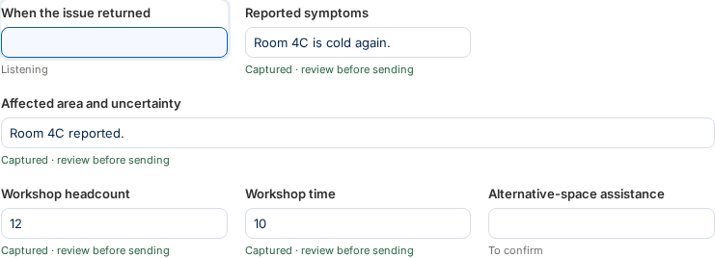  Actual form state after Alex asks the onset question and before Maya answers.  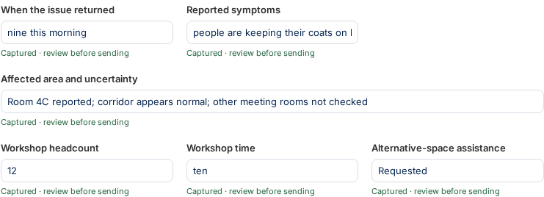  The populated fields later in the same conversation, still marked Captured — pending review.

AMAZON GREF / 09

Preserve the uncertainty
Capture the corridor observation without treating unchecked rooms as unaffected.
Alex “Have you noticed the same problem outside that room?”  Maya “No, the area just outside seems fine. But I haven’t checked the other meeting rooms.”  Alex “And is the workshop still twelve people starting at ten?”  Maya “Yes. We may need another room if it stays like this.”  Alex / Maya “Would you like me to request help finding another room? — Yes please. Request help finding another room.”  CAPTURED VALUES  Affected area: Room 4C reported; corridor appears normal; other meeting rooms not checked.  Headcount: 12. Workshop time: ten.  Alternative-space assistance: Requested.  PRESENTER ACTION  Review all six fields. The full affected-area qualification is retained in the message even when the single-line field clips its visible text. An alternative-space request is not a room reservation. | Actual captured fields. Long values continue horizontally in their input controls.  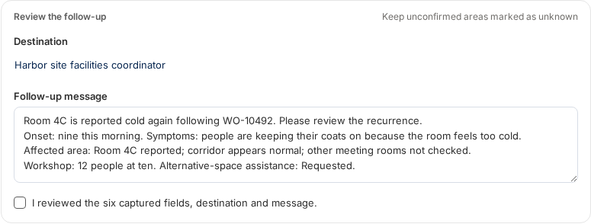  The saved message retains the complete qualification; scroll the native text area to review its remaining lines.

AMAZON GREF / 10

Review and submit the follow-up
The destination, message and six fields are reviewed before submission.
Alex “I’ll flag that the problem has returned after the previous work and ask the facilities team to reassess it. I’ll also include that you need help finding another room for the workshop.”  Maya “Thank you. Will they know this has already been worked on?”  Alex “Yes. I’m linking the previous work order and including today’s details so they have the history.”  PRESENTER ACTION  Review the Harbor site facilities coordinator destination and the prepared message. Check I reviewed the six captured fields, destination and message. Then select Submit follow-up.  REVIEW STATE  The review check enables submission. Manual edits remain under the representative’s control, and the source work order stays Completed. | 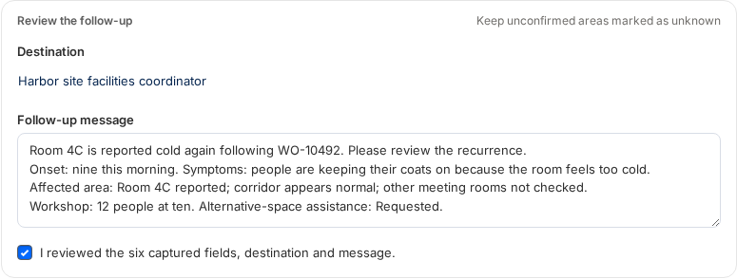  Actual reviewed state: the checkbox is selected and Submit follow-up is enabled.

AMAZON GREF / 11

Show acceptance before promising action
The Case draft is saved and the demonstration queue returns its receipt.
Alex “The follow-up has been accepted by the facilities queue, with the previous work linked. We’re waiting for the team to confirm their next step. I’ll also prepare the alternative-space request you asked for.”  Maya “That works. Please send me the reference.”  PRESENTER ACTION  Show F-10493 — Awaiting facilities review, linked to WO-10492. Select Request alternative space to prepare the workshop requirements.  WHAT THE RECEIPT MEANS  The demonstration queue accepted the follow-up. It does not confirm dispatch, repair or a reserved alternative room. The facilities Case remains open. | 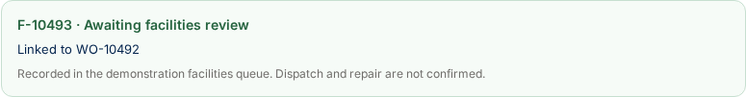  Actual saved receipt, explicitly labeled as a demo queue acceptance.

AMAZON GREF / 12

Keep the workshop running
The middle changes to a separate alternative-space request.
PRESENTER ACTION  After the facilities receipt, select Request alternative space. The room-request form replaces the main content; history remains available below it.  Alex “What time will the workshop end, and do you have a preferred location or equipment needs?”  PAUSE BEFORE THE ANSWER  Headcount and start time come from the reviewed facilities form. End time stays blank: an hour-long workshop is not assumed.  Maya “We finish at eleven this morning. Preferably on the same floor, and we need a screen.”  CAPTURED RESULT  The separate listening worker fills the end time and preferences. Unstated preferences can remain blank. Captured fields remain subject to Alex’s review. | 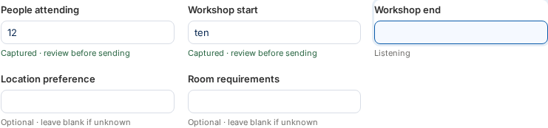  Actual second form before Maya states the end time; the prior reviewed headcount and start are prefilled.  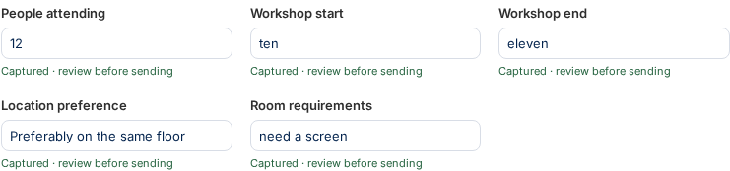  Actual spoken requirements in the native room-request form.

AMAZON GREF / 13

Request space without promising a booking
A separate receipt records the workplace team’s task.
Alex “I’ll include those requirements. The workplace team still needs to confirm availability.”  PRESENTER ACTION  Read back the details, check I reviewed the workshop details and room requirements with the employee, then select Send room request.  SAVED RESULT  Show the WS reference and Awaiting availability. It is a separate Salesforce Task on the same Case, not a room reservation.  Alex “Can I check back with a progress update by nine thirty, even if we are still waiting?”  Maya “Yes, a progress update by nine thirty would be helpful.”  AUTHORED TIME  All times here use the authored October 12, 2026, 9:10 a.m. demonstration clock. The progress update precedes the 10 a.m. workshop. | 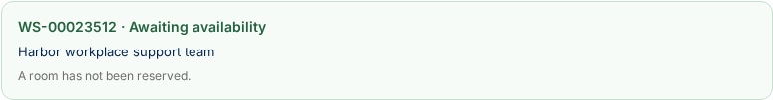  Actual room-request receipt; availability is pending and no reservation is confirmed.  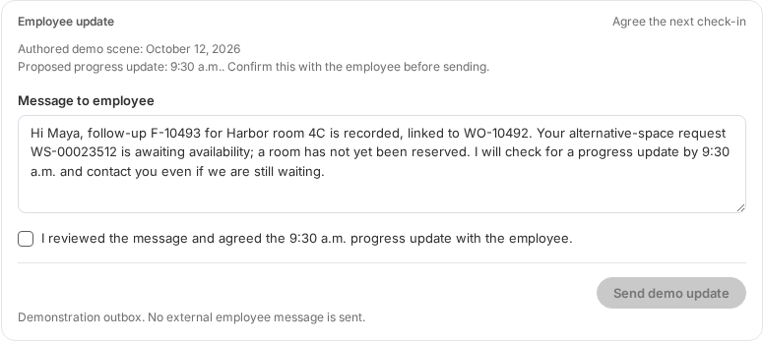  Employee-update draft includes both references and the agreed demonstration progress-update time.

AMAZON GREF / 14

Approve the employee update
The delivery result appears before Alex describes the message as sent.
PRESENTER ACTION  Agree a 9:30 a.m. progress update in the authored October 12 scene. Review both references and the message. Check the confirmation, then select Send demo update.  WAIT FOR THE RESULT  Show Delivered (demo). A Salesforce Task records the employee message and another records the next-update commitment. This demonstration outbox does not send a real employee SMS or email.  Alex “I’ve sent the reference and summary. Is there anything else I can help with today?”  Maya “No, that’s everything. Thank you.”  Alex “You’re welcome. I’ll follow up as agreed.”  ROLE AND OWNER  Alex is the spoken demo role. The actual delivery screen names the signed-in DevSDO presenter as owner. The 9:30 a.m. progress update is that agent’s commitment, not an Amazon SLA or repair ETA. | 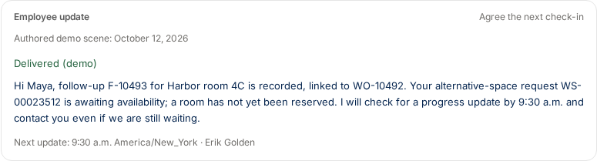  Actual Delivered (demo) result with the next-update time and saved owner.

AMAZON GREF / 15

Review the wrap-up
The call can be complete while the facilities Case remains open.
PRESENTER ACTION  After disconnect, select Wrap up. The existing DCC modal opens with the saved GREF summary and Case classification. Review or edit the summary, then select Mark as Complete.  REVIEW CONTENT  Three intents: room 4B status inquiry answered; recurring room 4C issue escalated; alternative-space request recorded. Prior work linked. Availability remains unconfirmed. Employee update recorded as delivered in the demo. Actual owner and next update retained.  FINAL STATE  Show Call complete · Case remains awaiting facilities review. The call is finished; no maintenance work order is marked repaired or completed by this interaction.  RECORDED RESULT  The qualified rehearsal saved five Tasks and left the Case open. | 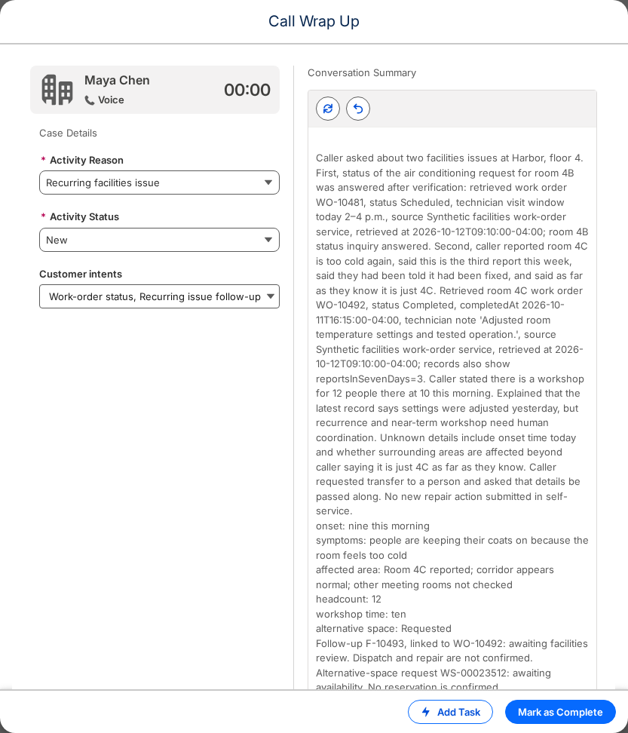  The shared DCC wrap-up modal, including the summary editor and Mark as Complete action.

AMAZON GREF / 16

Presenter reference
Use the screenshots as a visual guide to the deployed core journey.
START THE DEMONSTRATION  Open Amazon GREF in DevSDO. For live human pickup, open Phone/Omni, use the existing Connect SSO and select Allianz - Available. Call +1 800-520-8156.  SELF-SERVICE-ONLY BRANCH  If Maya needs only the room 4B status, she can say, “That answers my question. Thank you, goodbye.” The AI saves the interaction to the prepared Case and Connect ends the call without human routing.  WHAT HAS BEEN EXERCISED  A real Connect browser call: recorded welcome, configured preview verification, lookup, same-Case save and normal disconnect. Human queue routing was verified separately. The Salesforce stereo rehearsal exercises sourced guidance, both transcript speakers, both native forms, review, separate request receipts, demo delivery and DCC wrap-up.  REMAINING LIVE CHECK  Representative pickup, both headset directions and answer-time Copilot capture in the popped Case remain for the later live test.  SCOPE  Synthetic Maya/Harbor records; core English journey. The optional Spanish email and translation extension is not included. | 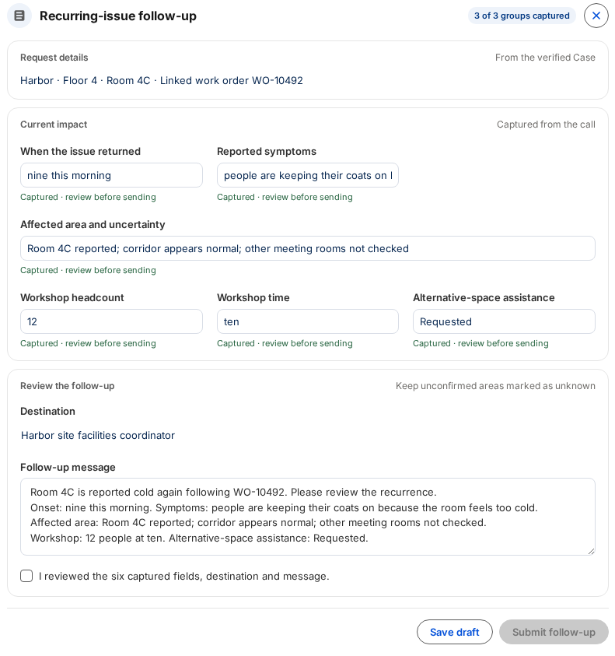  Full native follow-up form, shown before the representative’s review.

AMAZON GREF / 17

Use the shared transcript
The Transcript tab reuses the existing conversation component.
PRESENTER ACTION  Select Transcript in the right rail during the human conversation. Show both the employee’s answers and the representative’s questions. Return to Agent Assist to continue the guided workflow.  VERIFIED BEHAVIOR  The stereo rehearsal verifies both speakers in the transcript and the facilities and room-request fields captured from spoken answers. Switching tabs retains the Salesforce form and its review state.  REUSE  The app uses the installed Allianz console template, common Agent Assist transport, existing conversation transcript and shared DCC wrap-up. GREF-specific components provide facilities records, the native follow-up form and domain guidance.  CAPTURE REFERENCE  13 October 2026. Voice: 4927:v3. Copilot: 4928:v10. Primary Salesforce Case: 500DW00000Gb0iqYAB. Images are component crops; display content was not retouched. | 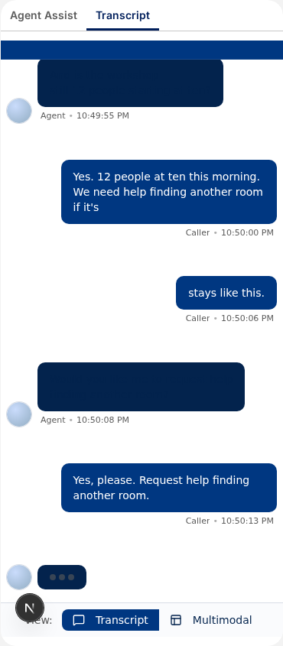  Actual shared transcript component during the live stereo rehearsal.

